SIMATS ENGINEERING (SAVEETHA SCHOOL OF ENGINEERING)
Department of Computer Science and Engineering
CO2 ASSESSMENT TOOL 2 – Architecture Design Assignment

Course Code: | CSA10 / CSA1007 | Course Title: | Software Engineering
CO Assessed: | CO2 | Assessment: | Assessment Tool 2 – Architecture Design Assignment
Weightage: | 20% | Total Marks: | 25
CO2 Statement: | Perform detailed requirements analysis, design scalable architectures, and prioritize features with a focus on cross-disciplinary skills
Student Name: | Ayyan Abhisheshan | Reg. No.: | 192411102
Date: | 30/07/2026 | Duration: | 60 minutes

Code of Conduct
I Ayyan Abhisheshan (192411102) certify that this submission is my original work and that I have adhered to the guidelines specified for this assessment. I understand that any violation of academic integrity rules will result in disciplinary action.
Signature of the Student: Ayyan Abhisheshan
Annexure A – Architecture Design Assignment
Instructions to Students:
Each student will be assigned an individual software project problem statement. Based on the assigned problem, analyze the system requirements and design an appropriate software architecture by applying software engineering principles. Your submission should demonstrate your ability to select, justify, and evaluate a suitable architectural style.

Question
Based on your assigned problem statement, perform an Architecture Design Analysis and prepare an architecture design report by answering the following questions:

1. Analyze System Requirements
- Study the given problem statement and identify the system objectives.
- Analyze the functional and non-functional requirements that influence the software architecture.
- Identify key quality attributes such as scalability, maintainability, reliability, availability, performance, and security.

2. Select a Suitable Software Architecture
- Select an appropriate architectural style for the proposed system (e.g., Layered Architecture, Client-Server, MVC, Microservices, Event-Driven, Service-Oriented Architecture, Serverless, or Hybrid Architecture).
- Justify why the selected architecture is the most suitable for the given problem.

3. Draw the Software Architecture Diagram
- Design a clear architecture diagram illustrating the overall structure of the proposed system.
- Include all major layers/components, databases, external systems, APIs, and communication mechanisms.
- Use appropriate software architecture notations and labels.

4. Explain Components and Their Interactions
- Describe the purpose and responsibilities of each architectural component.
- Explain how the components communicate and exchange data.
- Illustrate the overall workflow of the system.

5. Discuss Quality Attributes
Evaluate how the proposed architecture addresses the following aspects:
- Scalability
- Security
- Performance
- Reliability
- Maintainability
- Availability

6. Justify Architectural Decisions
- Explain the rationale behind your architectural choices.
- Discuss the trade-offs considered while selecting the architecture.
- Explain how the chosen architecture supports future enhancements, system integration, and long-term maintainability.

S.NO:14
Smart Aquaculture Farm Management System
1. Introduction
The architecture of the Smart Aquaculture Farm Management System is designed to provide real-time monitoring, intelligent decision-making, and efficient management of fish farming operations. The system integrates IoT sensors, cloud computing, databases, analytics, and a user-friendly interface. It collects environmental data from fish ponds, processes it, stores it securely, analyzes it using intelligent algorithms, and presents useful information to farmers through web and mobile applications.

2. System Architecture Overview
The architecture consists of five major layers:
- Data Collection Layer (IoT Sensors)
- Communication Layer
- Processing & Storage Layer
- Application Layer
- User Layer
Each layer performs specific tasks to ensure continuous monitoring and management of the aquaculture farm.

3. Architecture Layers
Layer 1: Data Collection Layer (IoT Devices)
This layer consists of sensors installed in each fish pond to continuously monitor environmental conditions.
Components
- Temperature Sensor
- pH Sensor
- Dissolved Oxygen Sensor
- Turbidity Sensor
- Water Level Sensor
- Ammonia Sensor
- Automatic Feeder
- Aerator Controller
Functions
- Measure water quality.
- Collect environmental data.
- Detect abnormal conditions.
- Send sensor readings to the gateway.

Layer 2: Communication Layer
This layer transfers sensor data from the fish ponds to the cloud server.
Components
- Wi-Fi
- GSM/4G
- LoRa
- MQTT Protocol
- Internet Gateway
Functions
- Secure transmission of sensor data.
- Continuous communication between sensors and cloud.
- Receive control commands from the server.

Layer 3: Processing and Storage Layer
This is the core of the system where all data is processed and stored.
Components
- Cloud Server
- Database Server
- Analytics Engine
- Machine Learning Module
- Notification Service
Functions
- Store sensor data.
- Process water quality information.
- Predict disease outbreaks.
- Generate feeding recommendations.
- Generate production reports.
- Trigger emergency alerts.

Layer 4: Application Layer
This layer provides software services for users.
Modules
Water Quality Monitoring
- Live sensor dashboard
- Water quality analysis
- Historical trends
Feeding Management
- Feeding schedule
- Feed optimization
- Feed history
Fish Growth Monitoring
- Fish weight records
- Growth analysis
- Biomass estimation
Disease Prediction
- Risk analysis
- Disease alerts
- Preventive recommendations
Farm Management
- Pond management
- Worker management
- Inventory management
Report Generation
- Daily reports
- Weekly reports
- Monthly reports
- Production reports
- Financial reports

Layer 5: User Layer
This layer includes all users who interact with the system.
Users
- Fish Farm Owner
- Farm Manager
- Farm Workers
- Veterinarian
- System Administrator
Functions
- Monitor ponds
- View reports
- Receive alerts
- Manage operations
- Update records

4. Architecture Diagram
SMART AQUACULTURE FARM MANAGEMENT SYSTEM
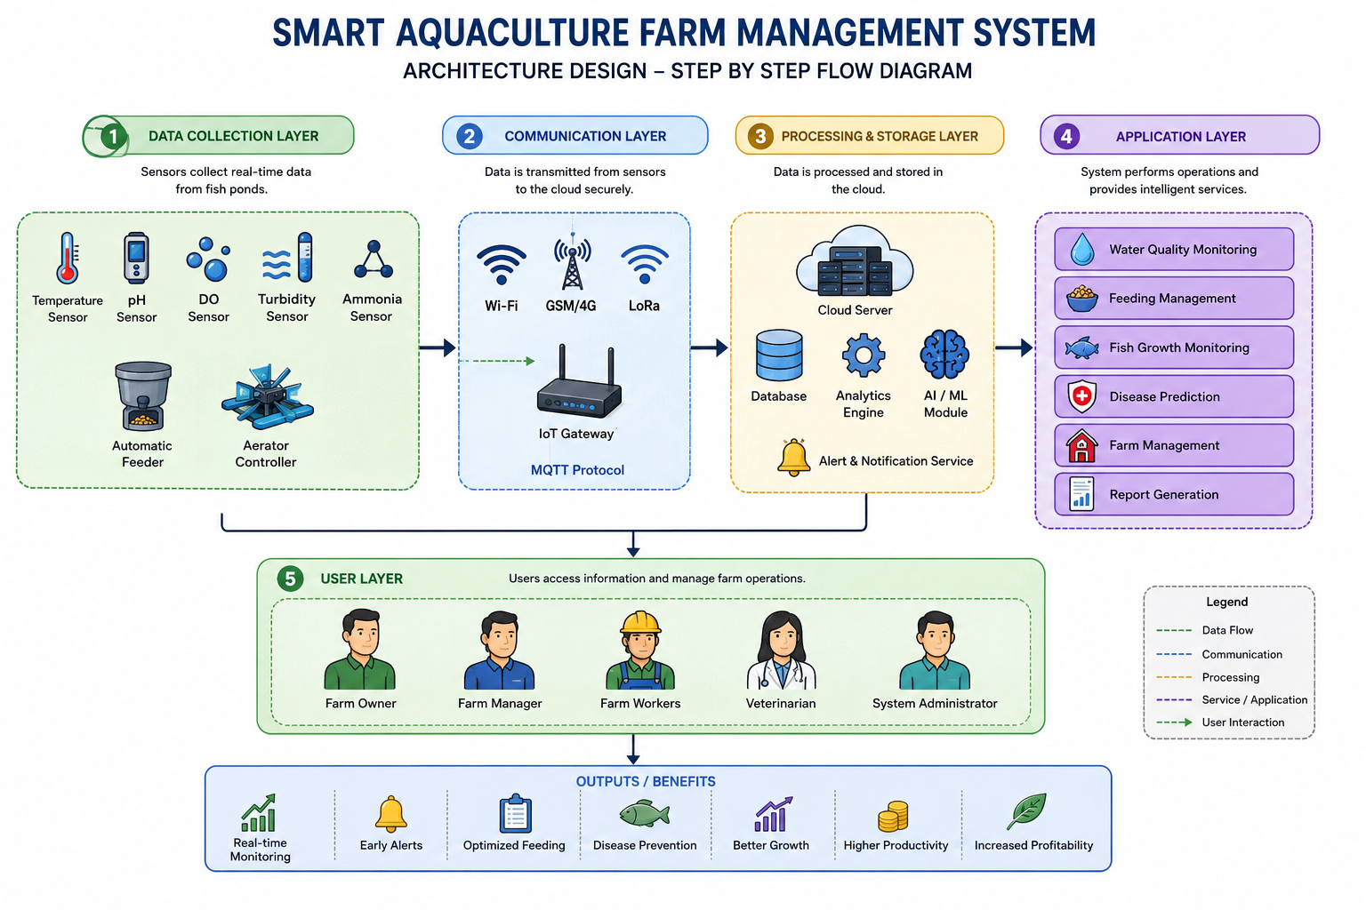

5. Module Architecture
Module 1: Water Quality Monitoring
Input
- Temperature
- pH
- Dissolved Oxygen
- Turbidity
- Ammonia
- Water Level
Output
- Live water quality dashboard.
- Warning notifications.

Module 2: Feeding Management
Input
- Fish age
- Fish weight
- Water temperature
- Feeding history
Output
- Feeding recommendations.
- Feed consumption report.

Module 3: Disease Prediction
Input
- Water quality
- Fish behavior
- Historical disease data
Output
- Disease warning.
- Recommended preventive measures.

Module 4: Fish Growth Monitoring
Input
- Fish weight
- Fish length
- Stocking details.
Output
- Growth chart.

6. Data Flow
- Sensors collect real-time pond data.
- Data is transmitted through Wi-Fi/LoRa/GSM.
- Cloud server receives and stores data.
- Analytics engine processes the data.

7. Hardware Requirements
- ESP32/Arduino/Raspberry Pi
- Temperature Sensor
- pH Sensor
- Dissolved Oxygen Sensor
- Turbidity Sensor

Conclusion
The proposed architecture for the Smart Aquaculture Farm Management System provides a scalable, reliable, and intelligent framework for modern fish farming. By combining IoT sensors, cloud computing, data analytics, and AI-based prediction modules, the system enables continuous monitoring, automated decision support, and efficient farm management. This architecture improves water quality management, reduces feed wastage, enables early disease detection, and enhances overall farm productivity, making it suitable for both small-scale and commercial aquaculture operations.

Rubrics for Calculation
Evaluation Criteria | Excellent (4 Marks) | Good (3 Marks) | Satisfactory (2 Marks) | Needs Improvement (1 Mark)
System Requirement Analysis (30%) | Thoroughly analyzes the problem statement, accurately identifies functional and non-functional requirements, and clearly explains quality attributes influencing the architecture. | Analyzes most requirements with minor omissions or limited explanation. | Identifies only basic requirements with partial analysis. | Requirement analysis is incomplete, inaccurate, or lacks clarity.
Selection of Software Architecture (25%) | Selects the most appropriate architectural style with strong technical justification aligned to system requirements. | Selects a suitable architecture with reasonable justification. | Architecture is partially suitable with limited justification. | Inappropriate architecture selected or justification is missing.
Architecture Diagram and Component Design (20%) | Produces a clear, complete, and well-structured architecture diagram with all major components, interfaces, and interactions accurately represented. | Diagram is mostly complete with minor omissions or notation issues. | Diagram includes only essential components and lacks sufficient detail. | Diagram is incomplete, unclear, or technically incorrect.
Component Interaction and Quality Attribute Analysis (15%) | Clearly explains component responsibilities, interactions, and thoroughly discusses scalability, security, performance, reliability, maintainability, and availability. | Explains most components and quality attributes with minor gaps. | Provides limited explanation of interactions and addresses only some quality attributes. | Component interactions and quality attributes are poorly explained or missing.
Architectural Justification and Technical Presentation (10%) | Provides strong justification for architectural decisions, discusses trade-offs and future enhancements, and presents a well-organized, professional report. | Provides adequate justification with minor gaps; report is well organized. | Limited justification with minimal discussion of trade-offs or future scope; report needs improvement. | Justification is weak or absent; report lacks organization and technical clarity.

Criteria | Mark
System Requirement Analysis (30%) | /5
Selection of Software Architecture (25%) | /5
Architecture Diagram and Component Design (20%) | /5
Component Interaction and Quality Attribute Analysis (15%) | /5
Architectural Justification and Technical Presentation (10%) | /5
TOTAL | /25

